**Källkoder**

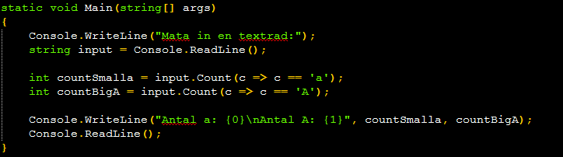

**Uppgift 1A**

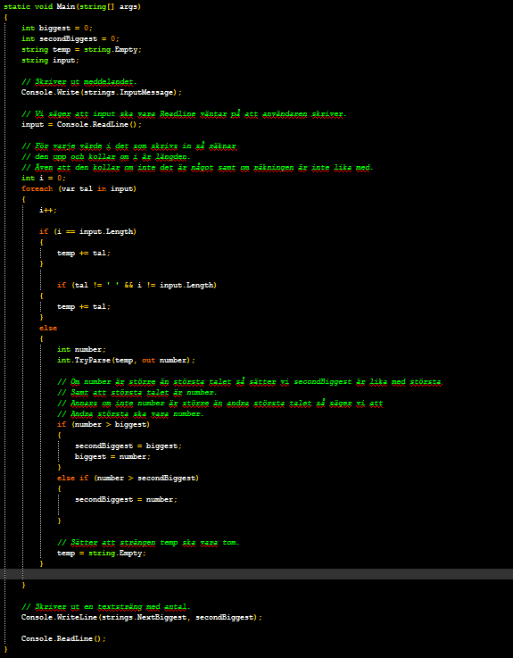

**Uppgift 1B**

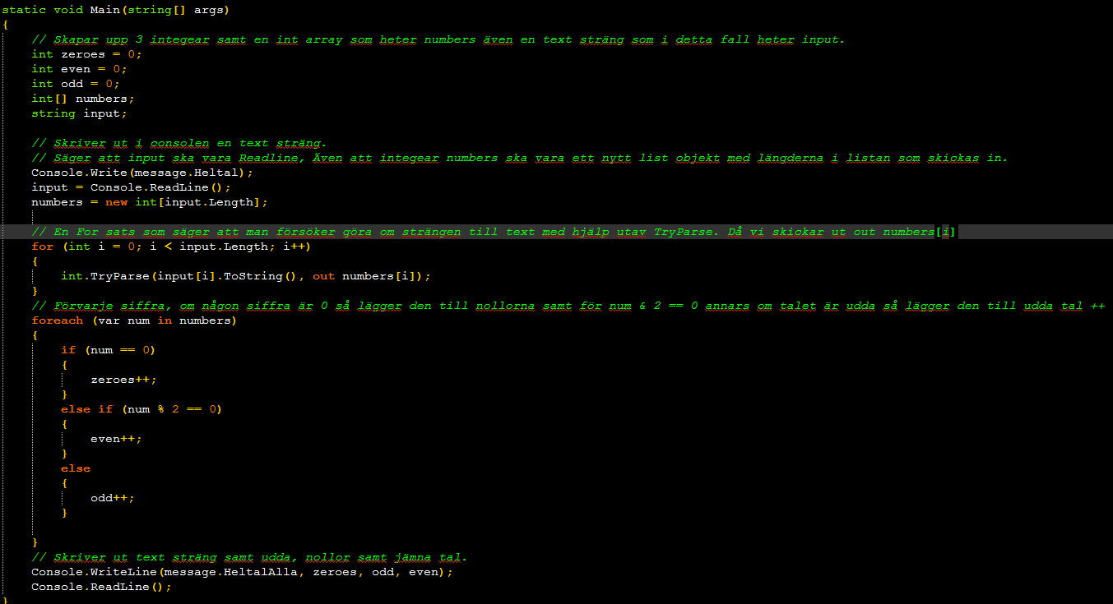

**Uppgift 1C**

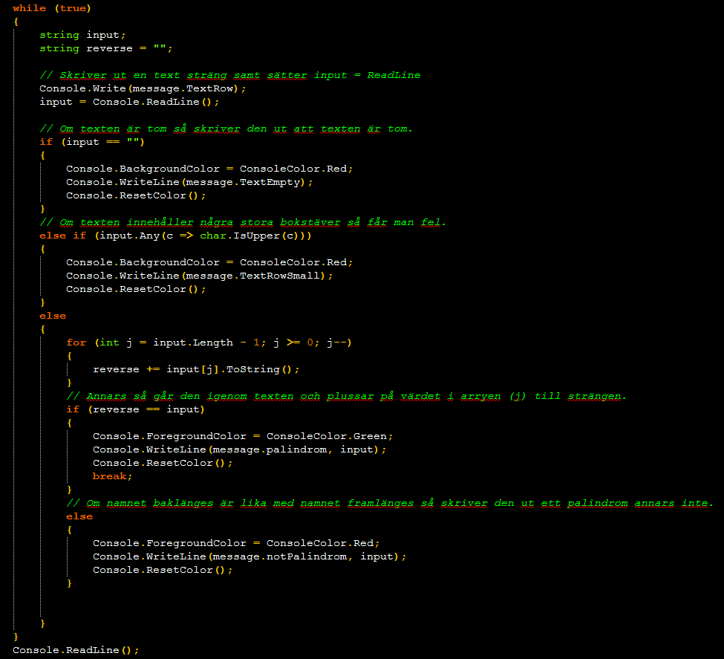

**Uppgift 3A**

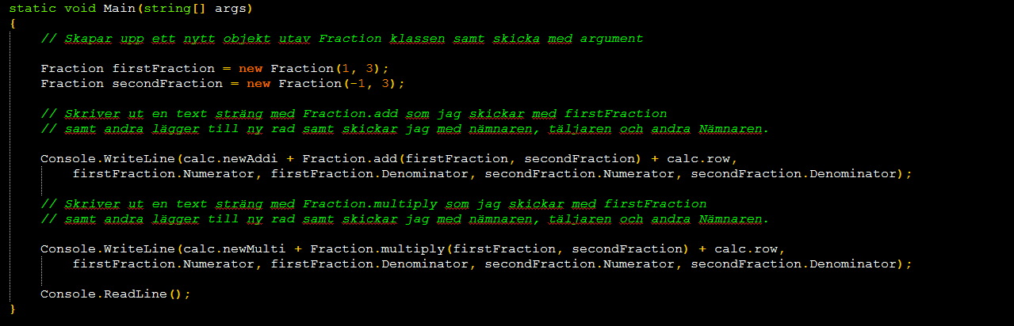

**Uppgift 3B- Program (Main metoden)**

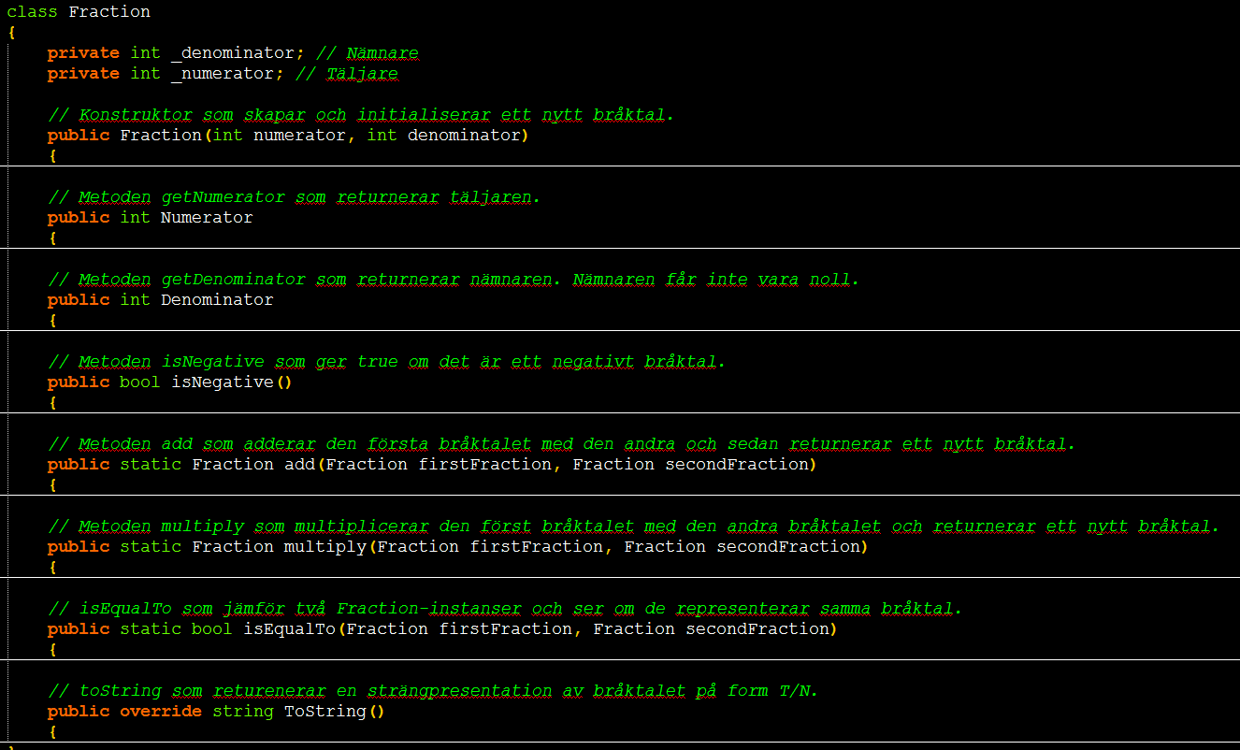

**Uppgift 3B-Fraction klassen (ihop stukad)**

**Referenser**

[**http://sv.wikipedia.org/wiki/Scrum**](http://sv.wikipedia.org/wiki/Scrum)

[*http://stackoverflow.com/questions/20032450/detect-if-a-string-contains-uppercase-characters*](http://stackoverflow.com/questions/20032450/detect-if-a-string-contains-uppercase-characters)

[*http://www.c-sharpcorner.com/Blogs/13822/program-to-check-whether-a-string-palindrome-is-or-not.aspx*](http://www.c-sharpcorner.com/Blogs/13822/program-to-check-whether-a-string-palindrome-is-or-not.aspx)

[*https://coursepress.lnu.se/kurs/iterativ-mjukvaruutveckling/forelasning-1/*](https://coursepress.lnu.se/kurs/iterativ-mjukvaruutveckling/forelasning-1/)

[*https://coursepress.lnu.se/kurs/iterativ-mjukvaruutveckling/forelasning-2/*](https://coursepress.lnu.se/kurs/iterativ-mjukvaruutveckling/forelasning-2/)